**DAILY ONLINE ACTIVITIES SUMMARY**

|  |  |  |  |  |  |  |  |  |
| --- | --- | --- | --- | --- | --- | --- | --- | --- |
| **Date:** | **25-07-2020** | | | | | **Name:** | **Kanaka BS** | |
| **Sem & Sec** | **6th & A** | | | | | **USN:** | **4al17cs039** | |
| **Online Test Summary** | | | | | | | | |
| **Subject** | | **-** | | | | | | |
| **Max. Marks** | | **-** | | **Score** | | | **-** | |
| **Certification Course Summary** | | | | | | | | |
| **Course** | **HTML CSS and Javascript for Web developers** | | | | | | | |
| **Certificate Provider** | | | **Coursera** | | **Duration** | | | **5 Weeks** |
| **Coding Challenges** | | | | | | | | |
| **Problem Statement: Python Program for Program to Print Matrix in Z form** | | | | | | | | |
| **Status: Solveds** | | | | | | | | |
| **Uploaded the report in Github** | | | | | **yes** | | | |
| **If yes Repository name** | | | | | <https://github.com/kanakabs/Daily-Status> | | | |
| **Uploaded the report in slack** | | | | | **yes** | | | |

**ONLINE COURSE**

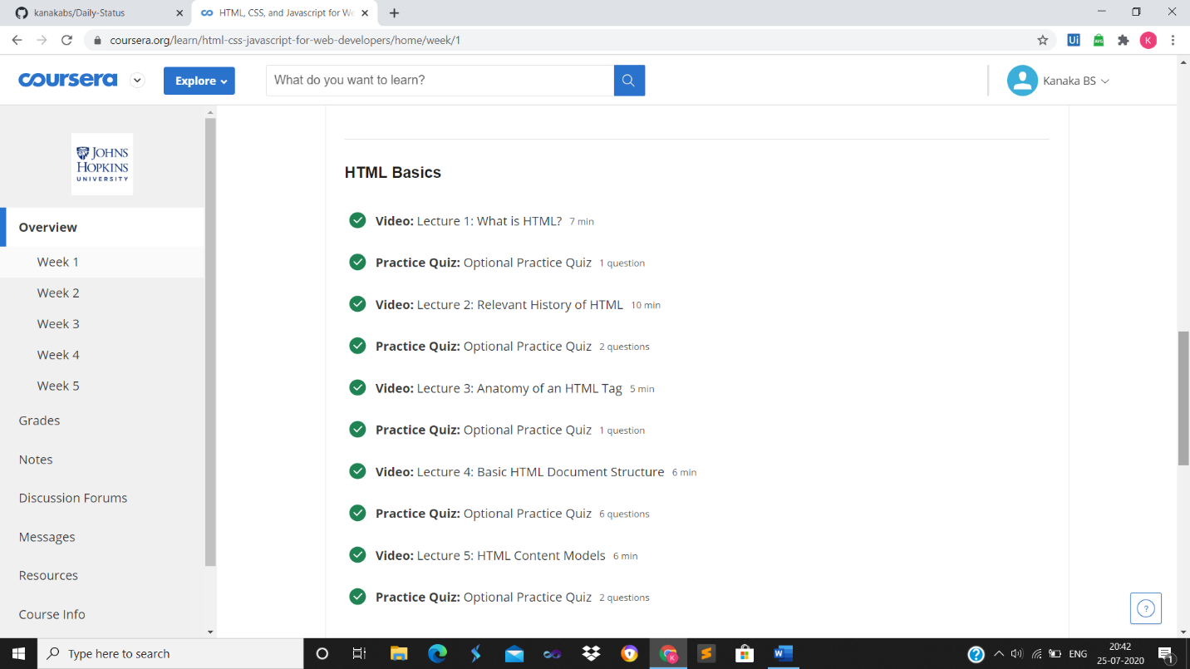

**ONLINE** **CODING**

**Python Program for Program to Print Matrix in Z form**

arr = [[7, 8, 6, 9],

[5, 4, 6, 7],

[7, 1, 3, 5],

[9, 8, 7, 5]]

n = len(arr[0])

i = 0

for j in range(0, n-1):

print(arr[i][j], end = ' ')

k = 1

for i in range(0, n):

for j in range(n, 0, -1):

if(j == n-k):

print(arr[i][j], end = ' ')

break;

k+= 1

i = n-1;

for j in range(0, n):

print(arr[i][j], end = ' ')

